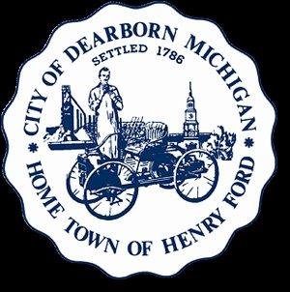 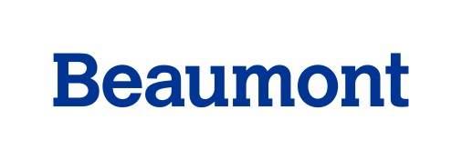

**Healthy Dearborn**

June 28, 2016

**Minutes**

**Meeting attendees**: Sanae Abbas, Zahra Abbas, Ali Almaklani , Debby Arko, Mary Baker, Toni Battle, Patrick Beauchesne, Corey Beckwith, Tracy Besek, Sophie Blaharski, Rachelle Bonelli, Chris Burkhalter, Bethany Burge, Pattie Burns, Danene Charles, Margaret Feistel, Brian Goocher,

Lyndsey Hage, Craig Kotajarvi, Jackie Lovejoy, Angela Kulka, Erica Lyght, Cynthia Mason, Chris Mayer, Dorothy McLeer, Deanne Murphy, Jeff Murphy, David Mustonen, David Norwood, Kate Pepin, Mary Petlichkoff, Carmel Price, Erin Reas, Glenn Savarese, Carla Schneider, Jim Thorpe, EmmaJean Woodyard.

1. Introductions were made.
2. The agenda packet materials were reviewed and they included flyers for upcoming bike ride and run events sponsored by the City of Dearborn for Homecoming. Also, a flyer for the weekly Healthy Dearborn Walk & Roll was included in the packet.
3. Four logos created by Beaumont’s internal marketing staff were distributed to each member so they could select the logo they liked best. Additionally, volunteers for the Homecoming weekend/Beaumont Healthy Dearborn tent, were solicited.
4. Strategic Plan Objectives, Action Steps & Timeline:

* The goal is to complete the Strategic Plan by July 19th. For those goals and objectives that depend upon the completion of other goals and objectives, the priority is to complete the plan for strategies that can be realistically achieved within one year. If more time is needed to complete the plan, Action Team members were encouraged to set up meetings with Sara Gleicher before July 19th.
* Student interns are helping with identifying data collection tools and measures for implementation of plan objectives.
* The Steering Committee will meet before July 19th to discuss the implementation plan.
* At the next coalition meeting on July 19th, each team will report out for the full group’s review and approval. After this reporting out, there will be time to enjoy the Environmental Center where the meeting will be held.
* Several teams do want to meet in August; an August meeting will be held on Tuesday, August 16th.

1. Announcements:

* July 8th – Volunteers are needed for the Dearborn Farmer’s Market since Chamber staff will be busy with a Golf Outing that day.
* Dearborn Recreation & Parks Department had a schedule of summer activities for kids, families and adults available for those interested.

**Future Meeting Dates:**

* Tuesday, July 19th at University of Michigan-Dearborn Environmental Interpretive Center – 4901 Evergreen Rd, Dearborn ([umd-eicenter@umich.edu](mailto:umd-eicenter@umich.edu))
* Tuesday, August 16th at 15500 Lundy Parkway, Mackinaw Room, Dearborn, 48126.

***Healthy Dearborn*** *is a community united to promote a healthier tomorrow!**Our Vision:**Dearborn, a thriving, diverse community, will fully embrace a unified culture of health where everyone enjoys whole health (mind, body, spirit), with equal access to healthy foods, health care, green space and opportunities for safe, active living.*

*Our Mission: We will create valuable opportunities for people in Dearborn to practice healthy lifestyles by enriching their minds, nurturing their bodies, and revitalizing their spirit.*