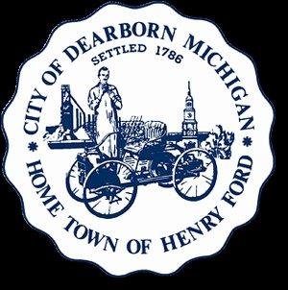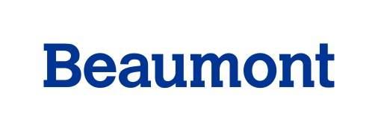
Healthy Dearborn
Tuesday, March 15, 2016
Minutes
Meeting attendees: Sanae Abbas; Zahra Abbas; Rawha Abouarabi; Virginia Adam; Dhuha Almadhagi; Ali Almaklani; Maryann Al-Aridhi; Anthony Anderson; Dennis Archambault; Lila Amen; Mary Baker; Maryanne Bartles; Corey Beckwith; Nancy Berry; Tracy Besek; Sophie Blaharski; Pattie Burns; Simone Calvas; Danene Charles; Colleen Cooper; Sara Doyle; Marak Daher; Paul Draus; Imad Ielbgal; Margaret Feistel; Brianna German; Sara Gleicher; Timothy Harrison; Rana Ismail; Gay Johnson; Zach Kerstein; Kassem Khraizat; Craig Kotajarvi; Steve LeMoine; Erica Lyght; Jeff Murphy; Alex Navarre; Dave Norwood; Osama Odeh; Kate Pepin; Mary Petlichkoff; Carmel Price; Pastor Satterwhite; Glenn Savarese; Carla Schneider; Deb Seder; Cristina Sheppard-Decius; Kathi Stadtmiller; Parth Suthak; Jim Thorpe; Emmajean Woodyard; Aber Yassine

- Introductions were made. Professor Paul Draus brought students from his class who were introduced and who generously and ably took Action Team notes and reported out draft objectives for each Team at the end of the meeting.
- A quick recap of progress made so far was made. Dr. Carmel Price informed the group about the effort to engage university researchers with Healthy Communities’ efforts. Dr. Price was integrally involved in “LiveWell Greenville”, a Healthy Community initiative in South Carolina. To date, 15 - 20 researchers have indicated they are interested in working with individual Action Teams and/or helping to design data collection and evaluation strategies.
- Osama Odeh, Wayne State University Master’s in Public Health student intern, was introduced. He will help Healthy Dearborn recruit and organize a Youth Advisory Council. He led the discussion on developing objectives for Healthy Dearborn Action Team goals. Following his presentation, the five Action Teams (Healthy Transportation; Healthy at Play; Healthy Foods; Healthy Schools; Healthy Worksites) met in groups to develop specific and measurable objectives for each strategic goal.

- All Action Teams succeeded in developing objectives. This work will continue at the April coalition meeting. The objectives were reported out. The group approved having Sara Gleicher review and refine objectives; this work will be emailed to each of the teams for review and approval. The next step in the strategic plan process will be to develop specific strategies/action steps that need to occur in order to achieve goals and objectives. The draft objectives are on page 3 of these minutes.

- The meeting was adjourned at 10:05 a.m.
Meeting Results:
- Coalition progress reviewed
- Research agenda reviewed
- Draft strategic plan objectives for goals identified for all 5 Action Teams
Future Meeting Dates:
- Tuesday, April 19
- Tuesday, May 17
- Tuesday, June 28th
- Tuesday, July 19th

Healthy Dearborn is a community united to promote a healthier tomorrow!
Our Vision: Dearborn, a thriving, diverse community, will fully embrace a unified culture of health where everyone enjoys whole health (mind, body, spirit), with equal access to healthy foods, health care, green space and opportunities for safe, active living.
Our Mission: We will create valuable opportunities for people in Dearborn to practice healthy lifestyles by enriching their minds, nurturing their bodies and revitalizing their spirit.

