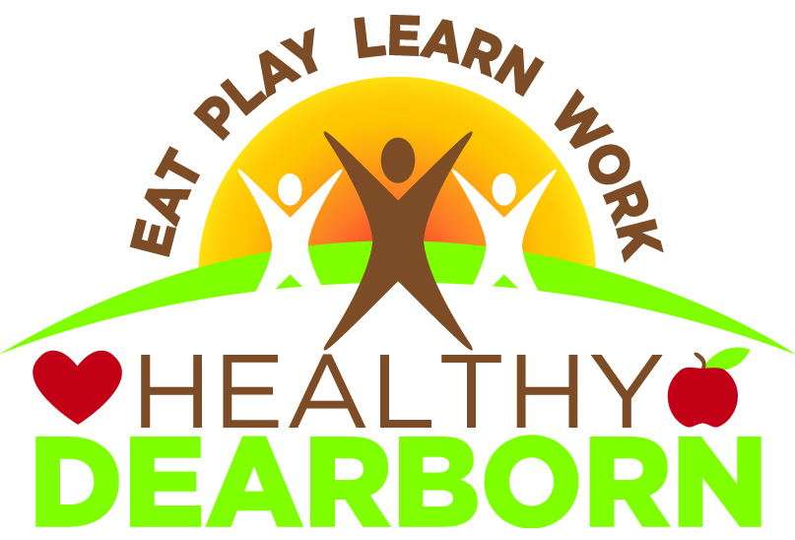

**Coalition Meeting**

**VISION**

**Dearborn, a thriving diverse community, will fully embrace a unified culture of health where everyone enjoys whole health (mind, body, spirit) with equal access to healthy foods, health care, green space and opportunities for safe, active living.**

**MISSION**

**We will create valuable opportunities for people in Dearborn to practice healthy lifestyles by enriching their minds, nurturing their bodies and revitalizing their spirit.**

**www.healthydearborn.org**

**cid:image001.png@01D23E72.FB113B10Join us! Join the Healthy Dearborn Facebook Page!**

**Join us on Twitter:** [Image result for twitter logo for print use](http://www.bing.com/images/search?q=twitter+logo+for+print+use&id=A7C968625991B60A458B56154D9629B058A11976&FORM=IQFRBA) **@healthydearborn**

**Ford Community & Performing Arts Center**

**15801 Michigan Avenue, Dearborn 48126 – Studio A**

Community meeting to discuss the support and promotion of healthy lifestyles in Dearborn   
 **Tuesday, January 16, 2018**

**8:00 a.m. – 10:00 a.m.**

**AGENDA**

**Facilitator – Dr. Carmel Price  
Guest Speaker – Dr. Abdul El-Sayed**

8:00 a.m. Refreshments, coffee and sign-in

8:30 a.m. **Meeting begins** – Welcome & introductions

8:40 a.m. Overview of meeting goals and activities

8:45 a.m. Action team break-outs

9:40 a.m. Presentation by Guest Speaker Dr. Abdul El-Sayed

9:55 a.m. Next steps & announcements

**Healthy Dearborn Meeting Schedule:**

* **Tuesday, February 20th at City Hall ArtSpace Lofts!  
   13615 Michigan Avenue, Dearborn 48126**
* **Tuesday, March 20th, location TBD**

**Healthy Dearborn is a community united to promote a healthier tomorrow!   
  
Our Vision: Dearborn, a thriving, diverse community, will fully embrace a unified culture of health where everyone enjoys whole health (mind, body, spirit), with equal access to healthy foods, health care, green space and opportunities for safe, active living.**

**Our Mission: We will create valuable opportunities for people in Dearborn to practice healthy lifestyles by enriching their minds, nurturing their bodies, and revitalizing their spirit.**

**HEALTHY DEARBORN COALITION   
MEETING MINUTES  
11/21/17  
  
15500 Lundy Parkway, Dearborn MI 48126**

**Attendees:** Zahra Abbas, Nasser Alijabbari, Ali Baleed Almaklani, Lila Amen, Dennis Archambault, Mary Baker, Jeanne Barcelona, Maryanne Bartles, Sophie Blaharski, Rachelle Bonelli, Bethany Burge, Mitzi Cardona, Erin Centeio, Arden Ciaciuch, Dan Cook, Heather Dillaway, Paul Draus, Mary Jo Durivage, Ali Hachem, Rachel Higgins, Mona Hijazi, Rana Ismail, Alicia Jackson, Craig Kotajarvi, Stephanie Krajnik, Erica Lyght, Melissa Makled, Cynthia Mason, Michael Mroczyk, Dave Norwood, Kate Pepin, Mary Petlichkoff, Carmel Price, Waddah Saeed, Glenn Savarese, Gadah Sharif, Nancy Short, Tameka Spruce, Sharon Stanek, Rose Wellman, Eric Woody, Lacea Zavala

The meeting began with introductions and a review of the meeting’s goals and activities. The goal of the meeting was for action teams to complete their strategic plan objectives and priorities. Teams were instructed to discuss the new ideas generated by coalition meetings during the October meeting to determine if objectives needed to be revised or tweaked, and then to assign levels of priority to the objectives. Action teams met for one hour.

The following objectives have been identified for action teams:

**Healthy Foods - Outcome Goal: By June 2022, the City of Dearborn will support a culture of health that increases access to healthy foods and promotes healthy eating.**

**PROPOSED PRIORITIZED OBJECTIVES**  
  
1. Increase awareness & knowledge about importance of healthy foods to improve  
 health.   
 * Include food pantries as data point for research.

2. Increase skills to make healthy choices with motivational activities and  
 incentives.   
 *Cooking Matters

3. Increase access to healthy foods and programs to support healthy eating.  
 *Partner with Healthy at Play, e.g., end bike rides at a restaurant, create bike tour   
 or walking tour from restaurant to restaurant. Whenever there is a physical   
 activity with recreation program, the snack should be healthy.   
 * Community gardens have excess produce – need distribution logistics

4. Support growing & consuming local food products.  
 *Work with seniors for seed program  
 *Intergenerational garden/cooking/preserving

3 year objectives: Training servers; erect hoop houses at community gardens;   
  
How to build collaboration with Healthy Schools team, to change cultue at schools. Incentives are not healthy, fundraisers are not healthy; how to engage students with Walk & Rolls.

**Healthy at Play – Outcome Goal: Dearborn residents will increase their physical activity on a regular basis.**

**PROPOSED OBJECTIVES**  
  
1. Create a network of collaborating org’s that provide physical activities.   
 * schools, churches, mosques, service clubs, senior centers, DPS

2. Increase participation in regular physical activity by 30 minutes.  
 *Create an app for Healthy Dearborn participants

3. Promote benefits of physical activity through presentations, events and social  
 media.   
 *Suggest how to track steps

**Healthy Schools - Outcome Goal: All Dearborn Public School students are meeting the state recommended standards for physical activity and are consuming the recommended amount of daily fresh fruits and vegetables.**

**PROPOSED OBJECTIVES**

1. Increase knowledge on healthy lifestyles and healthy food access in schools by collaborating with school leaders and community stakeholders.
2. Increase physical activity during the school day at elementary level.
3. Implement healthy nutrition lessons during the school day at elementary level.
4. Promote the Year of Health, led by City in partnership with Schools & Beaumont.

**Healthy Transportation - Outcome Goal: By 2022, all Dearborn residents will increase their use of non-motorized transportation options that will be safe, inviting and accessible to them, regardless of where they live.**

**PROPOSED OBJECTIVES**

1. Develop a bike & pedestrian transportation master plan for Dearborn**.**
2. Promote public acceptance and support for non-motorized and public transportation.
3. Collaborate with Healthy Schools on Safe Routes to Schools Program.

**Healthy At Work - Outcome Goal: By 2022, create a more health conscious workforce in Dearborn through engaging 50 businesses with wellness program providers in Dearborn.**

**PROPOSED OBJECTIVES**

1. Distribute employer needs survey to Chamber of Commerce members.  
   Tasks: 1) using survey results, develop sustainable action plan, to respond to employer needs identified in the survey, to link to community wellness opportunity; 2) Contact UAW Local 600 or corporations for survey – regarding cafeteria options, habits, include other unions
2. Increase employee based wellness program provider list.
3. Create Healthy Dearborn starter toolkit. (this allows team to maintain contact while in the process of connecting with providers. Possibly use AHA material)

Ways to collaborate:

* Healthy Schools – involve the youth; provide work support to parents, education on packing healthy lunch
* Healthy Transportation – promote Dearborn Bike Share program to organizations through various communication channels. Listen for updates on bike lanes in Dearborn
* Healthy Foods – promote AHA policy toolkit to remove sugary beverages at the workplace; provide organizations with healthy snack options.

After teams came back as a large group, coalition member Michael Moroczyk provided information on AIS and also suggested ways to enhance intra-action team communication through use of a form. Michael is a trained AIS therapist and offers classes for free at his church. AIS stands for “Active Isolated Stretching”. It is a specific stretching program developed more than 30 years ago by a kinesiologist and therapist. AIS helps professional and amateur athletes become more agile and suffer fewer injuries. It is highly effective.

The meeting adjourned at 10:06 a.m.

**Future Meeting Dates:**

* No meeting in December
* Tuesday, January 16th, Ford Community & Performing Arts Center, Studio A