Dearborn Open Streets 2020
Volunteer Information

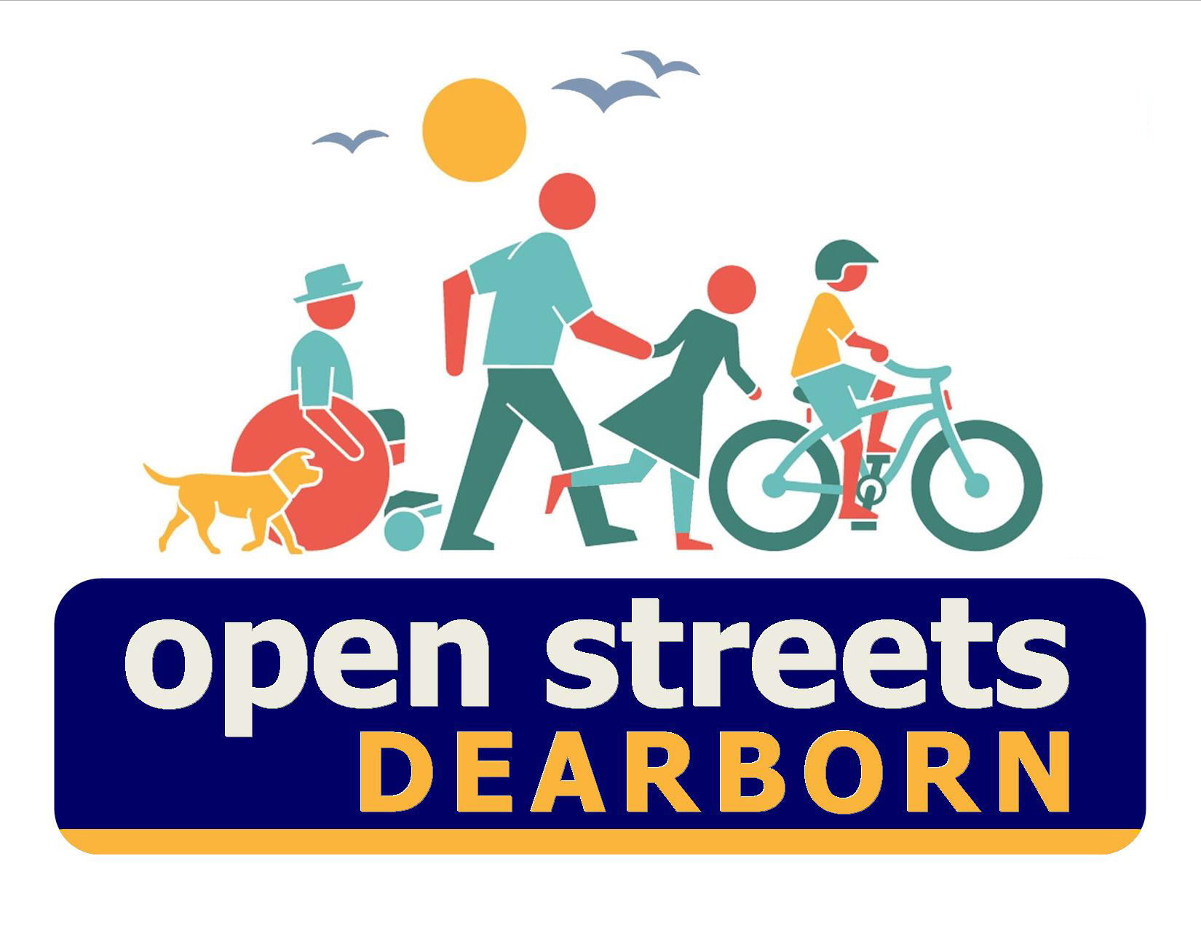
Sunday, June 28th, 2020
11:00 am - 3:00 pm

Monroe Street
from West Village Drive to Dartmouth Street
For more info: https://www.healthydearborn.org/open-streets-2020
OR (313) 943-2159

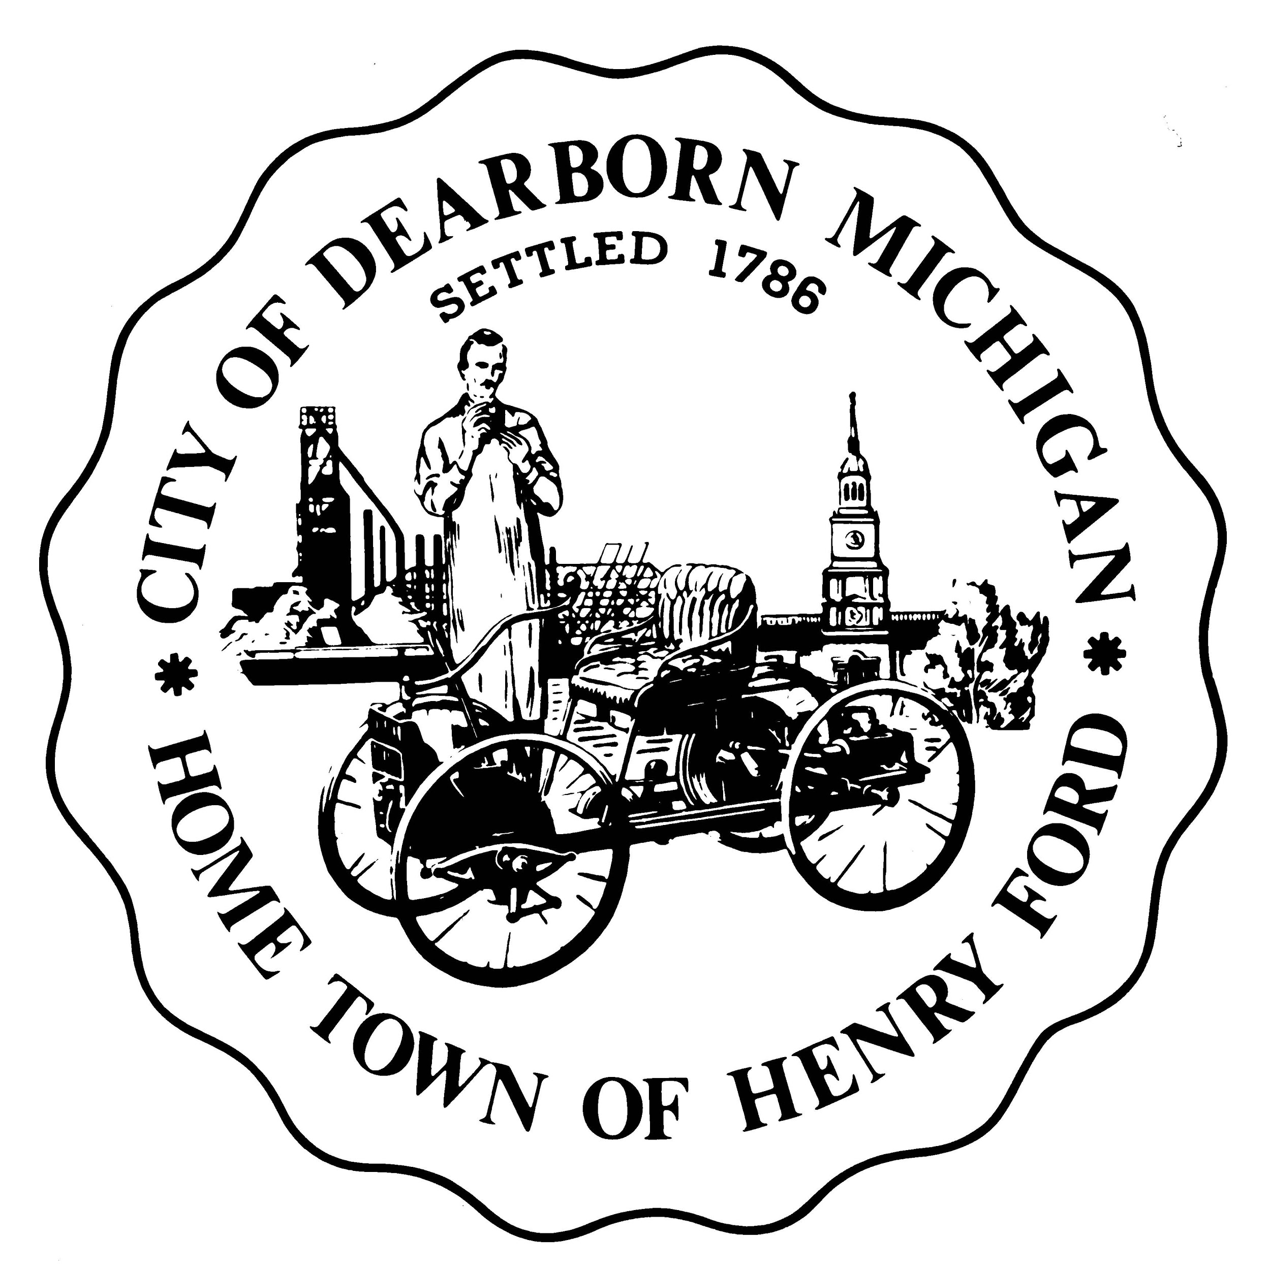
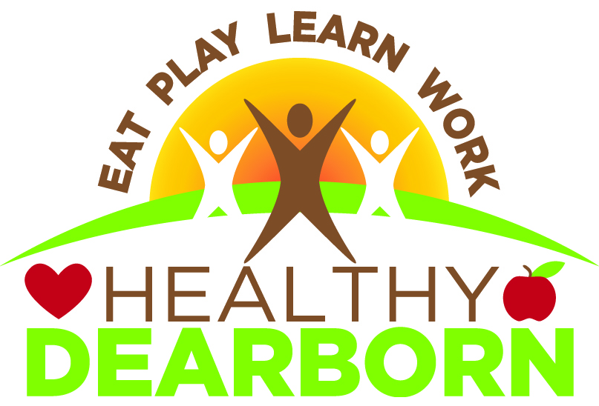
What is Open Streets?

Open Streets is a movement felt around the world. Open Streets shuts down the streets for motor-vehicle traffic and allows individuals to use the streets to walk, bike, and play. This movement is intended to create a sustainable movement that encourages physical activity in the community with the intention that streets open to walking, biking, and playing are eventually considered a “norm” for the citizens.

At Open Street events, “hubs” are created to provide free physical activities to the participants of this event. These hubs of activities allow individuals to experience different forms of physical activity while getting active.

In 2019, Healthy Dearborn hosted the first-ever Dearborn Open Streets in the south-end of Dearborn on Sunday, October 6th. Dearborn Open Streets 2020 will take place on Sunday, June 28th from 11:00 am to 3:00 pm. The route stretches across over 2.0 miles. The main route is Monroe Street beginning at Michigan Avenue and ending at Dartmouth Street. Information on Open Streets will be posted and continually updated on our website: https://www.healthydearborn.org/open-streets-2020.

Now, we are reaching out to partner with you! This movement is only possible with community volunteers and sponsors to help promote, support, and sustain the event. Please read on to find out how you can participate!

Map of Open Streets 2020
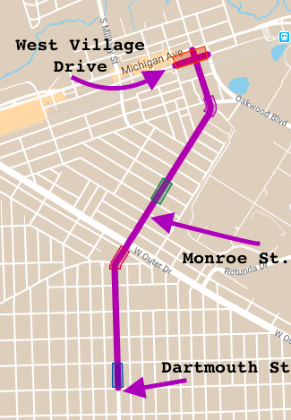

Objectives of Open Streets Dearborn
- Join the 400+ cities worldwide that host Open Streets events
- Address obesity and other health problems by promoting active living
- Encourage social interaction between all ages, cultures and backgrounds in the community
- Promote Dearborn as an aspirational bike/walk friendly city, as a city that uses fun, accessible activities to enhance mobility, get people involved, and create more vibrant, healthy and equitable communities
- Encourage non-motorized transportation as a safe alternative to cars
- Increase business for local businesses
- Crease a positive experience for families
- Build a shared vision for the long-term sustainability of Dearborn

VOLUNTEER OPPORTUNITIES
There are different volunteer opportunities for you to enjoy:

HUB Activity Volunteer
What?
Prepare and host a physical activity: create the physical activity, “run” the activity on the day of the event, and provide any necessary equipment. The activity should be accessible for people of all ages and abilities.
Where?
The activity will take place on the Open Streets route at one of the HUB locations. Once the location is determined, a confirmation email will be sent to the HUB activity volunteers to provide them with information.
When?
Sunday, June 28th, 2020, 11 am – 3 pm. You can volunteer your activity for a two hour shift or stay the whole time. Please let us know what times you are available to volunteer your activity and the time frame of the activity. The volunteer form is on page 6.
Example HUB Activities
- Physical Activity: Dance class, fitness class, yoga class, meditation, group fitness, tai chi, karate, sports game
- Health Promotion: Provide health information through games and information tables
- Music: Bands and individual artists
- Arts and Culture: Visual arts & crafts, performance arts, and physical arts and crafts (sidewalk chalk)
- Free Services: Nutritional counseling, bike repairs, and more
- Free Goods: “Hydration station”, juice bar, and healthy treats.

Event Volunteer
What?
We need individuals to monitor intersections, conduct evaluations surveys, take pictures, and other duties.
Where?
There are different intersections throughout the Dearborn Open Streets Route that will need to be monitored. Other volunteers who are conducting surveys and taking pictures are free to roam throughout the event.
When?
The day of the event, Sunday, June 28th, 2020. The volunteer form includes a schedule. Please let us know what times you are available to volunteer your activity and the time frame of the activity. The volunteer form is on page 6.

Outreach volunteer
What?
  - We want to utilize many ways of promoting the event including print and social media, radio, door-to-door outreach, snail mail, flyers and presentations. If you love to create flyers, or do social media, or go door-knocking, please volunteer! We always need people who have Arabic fluency in speaking and writing.
Where?
Promote Open Streets on all platforms of social media. Furthermore, promote open streets throughout the City of Dearborn and surrounding communities. Visit local businesses, inform your neighbors
When?
Start promoting now through the day of the event! Contact us for information, flyers and suggested key messages! Please fill out the volunteer form on the next page.

Volunteer Form
** Use this link to fill out an online volunteer form
https://forms.gle/tyLoJCpbWCY99NAs5

Contact Information
Name: _____________________________________________________

Email Address: ______________________________________________

Phone number: ______________________________________________

Please fill out the schedule below informing us of your availability and/or the time frame of your activity.
Dearborn Open Streets 2020 Schedule
Time | Availability
11:00am
11:30am
12:00pm
12:30pm
1:00pm
1:30pm
2:00pm
2:30pm

I would like to volunteer:
____ Provide a HUB activity
____ Volunteer on the day of the event
____ Outreach volunteer

Volunteers for the HUB ACTIVITIES:
Summary of the physical HUB activity:

Questions? Go to https://www.healthydearborn.org/open-streets-2020
OR call (313) 943-2159
____________________________________________________________
Example of how to fill out your volunteer form
Name: __John Smith_______________________________________
Email Address:______Johnsmith@gmail.com___________________
Phone Number: ______(123) 456-7890________________________

Dearborn Open Streets 2020 Schedule
Begin at Time | Availability (X)- Yes
11:00am | X -- 30 Minute Yoga Class
11:30am
12:00pm
12:30pm
1:00pm
1:30pm
2:00pm
2:30pm

I would like to volunteer:

__X__ Provide a HUB activity
____ Volunteer on the day of the event
____ Outreach volunteer
Volunteers for the HUB ACTIVITIES:
Summary of the physical HUB activity
I will provide a thirty-minute yoga class. This class will be accessible to individuals of all ages and I can make modifications so that the class fits the needs of individuals of all abilities. Students must bring their own mats!

