***Healthy Dearborn is a community united to promote a healthier tomorrow!*   
 *Our Vision:* Dearborn, a thriving, diverse community, will fully embrace a unified culture of health where everyone enjoys whole health (mind, body, spirit), with equal access to healthy foods, health care, green space and opportunities for safe, active living.**

***Our Mission:* We will create valuable opportunities for people in Dearborn to practice healthy lifestyles by enriching their minds, nurturing their bodies, and revitalizing their spirit.**

**HEALTHY DEARBORN COALITION   
MEETING MINUTES  
10/17/17  
  
Ford Community & Performing Arts Center, 15801 Michigan Ave. Dearborn**

**Attendees:** Zahra Abbas, Mariam Akhdar, Ali Baleed Almaklani, Lila Amen, Dennis Archambault, Becca Austin, Abe Baiz, Batoul Baiz, Toni Battle, Rachelle Bonelli, Bethany Burge, Chris Burkhalter, Danene Charles, Alex Chmara, Arden Ciaciuch, Rachael Dombrowski, Paul Draus, Mary Jo Durivage, Brandi Ekpiken, Nicole Frantz, Ali Hachem, Tim Harrison, Mona Hijazi, Craig Kotajarvi, Stephanie Krajnik, Noel Kulik, Kelsey Lemay, Steve LeMoine, Erica Lyght, Chris Mayer, Teia McGahey, Quentin Moore, Michael Mroczyk, Dave Norwood, Kate Pepin, Mary Petlichkoff, Carmel Price, Michael Rudell, Glenn Savarese, Gadah Sharif, Nancy Short, Sharon Stanek, Maha Taranish, Theresa Tejade, Rose Wellman

The meeting began with introductions and a review of Healthy Dearborn’s progress and commitment to health equity. Healthy Dearborn members have achieved numerous successes. (See Attachment A) As we develop the Year 2 strategic plan, we are building on these successes. We are also taking into consideration new information including data from 500 Cities Project showing health disparities in Dearborn. We also briefly highlighted what is meant by “health equity”. (See Attachment B)

Following review of HD progress and focus for its Year 2 plan, participants were provided instructions for the small group activity. In response to coalition members’ requests for increased communication across action teams, and to escape the same-old- meeting-format-rut, a new approach was tried.

Each coalition member selected an action team group to participate in that was not their “home” action team. The activity was designed to solicit fresh perspectives and new ideas for each action team’s proposed objectives, by inviting “new” members to review and provide feedback on them. Everyone was encouraged to voice his/her idea, even if it suggested a new or revised objective for that action team. (See Attachment C) Identification of new resources for project implementation was encouraged. (See Attachment D) The last step in the exercise asked people to also identify possible areas for collaboration across action teams. Each action team group was led by an “original” action team member who could answer questions and provide information about the history and intent behind proposed objectives.

The following ideas generated for each action team:

**Healthy Foods - Outcome Goal: By June 2022, the City of Dearborn will support a culture of health that increases access to healthy foods and promotes healthy eating.**

**PROPOSED OBJECTIVES**  
  
1. Increase awareness & knowledge about importance of healthy foods to improve health.

2. Increase skills to make healthy choices.

3. Increase access to healthy foods and programs to support healthy eating.

4. Support growing & consuming local food products.

**NEW IDEAS**

* Include food pantries as data point for research/Forgotten Harvest drop-off points, if applicable
* Community gardens have excess produce – need distribution logistics
* Doctors need to address healthy earing with patients, medical schools need to teach nutrition to medical students
* Popular peer pressure – need to increase demand
* Loyalty program – dinner and a movie
* Time & skills to cook health – Cooking Matters
* Training servers
* Targeting schools to reach families
* Home Ec classes
* How do we get invited to bring education/messaging so that people can receive it
* Create healthy restaurant month – official proclamation, Taste of Dearborn, restaurant week model of healthy appetizer, entrée, dessert for $20
* Connect with Veg MI to advertise vegetarian/vegan friendly restaurants
* Education about how to use, preserve ingredients in CSAs
* Assess greenhouses/botany classes in schools
* Erect hoop houses at community gardens
* Work with seniors for seed program
* Intergenerational garden/cooking/preserving
* Gardens at senior living – increase media, programming, outreach
* Create list of community gardens/plots
* CSA fair – deadlines for applying for CSAs, promote options
* Senior Project Fresh- educate/increase awareness
* DUFB
* Menu layout review to improve choice architecture
* Assess lunch lines
* Whenever there is a physical activity/recreation program, the snack should be health – Parks & Rec, have a nutritional standard for travel teams
* CREATE THE DEMAND
* Restaurant priority – loyalty program
* Review kids menu options
* Identify health heroes – show that it’s possible
* Michigan Harvest of the Month – promote seasonality and educate how to use it
* At least 1 store in Double Up food Bucks – perhaps Greenland?

**RESOURCE SUGGESTIONS**

* Restaurant owners!
* MSU Extension

**COLLABORATION SUGGESTIONS**

* Healthy at Play on Healthy at Play proposed objective #1
* Healthy Schools on Healthy Schools proposed objective #1

**Healthy at Play – Outcome Goal: Dearborn residents will increase their physical activity on a regular basis.**

**PROPOSED OBJECTIVES**  
  
1. Create a network of collaborating org’s that provide physical activities.

2. Increase participation in regular physical activity by 30 minutes.

3. Promote benefits of physical activity through presentations, events and social media.

**NEW IDEAS**

* Give pedometers to all residents who want them for the objective to increase activity. “Healthy Taylor” – check with Sara
* How do we motivate people to get out and be active and together
* Splashpads increase activity
* For winter – indoor activity opportunities for drop-in play (unstructured/organized with parents supervising own children) – identify spaces where these activities can take place
* Can we use “senior center” space for other social gatherings – can be book it?
* School, churches, mosques – what’s going on already
* Services clubs – activities
* Conduct gaps analysis of senior centers, schools, churches, mosques, service clubs to identify existing and needed activities
* Another category – play, leisure
* Service opportunities – guidance counselors, parochial schools, public schools, churches, key club, etc.
* GIS data of all information – data/relationships
* Look at cost factor with regard to physical activity (spreadsheet location/price/activity
* Dearborn Public Schools – circular for public education – use as a resource for importing into resource list
* Gap – women only activities
* On website
* Ice skating rinks, parks
* Resources for importing data – seasonal activities brochure (all activities); Dearborn Public schools website – by school/activity; private & local businesses
* Map of parks, schools, colleges – equity. Color coded maps of activities to recognize equity
* Summer park programs – have either in all parks (or in proximity of all neighborhoods)
* Safety issues in regard to children being at parks

**RESOURCE SUGGESTIONS**

* Playworks – grant – coaches to come & teach schools (@ parks?)

**COLLABORATION SUGGESTIONS**

* Healthy Transportation on Healthy at Play’s objective #1

**Healthy Schools - Outcome Goal: All Dearborn Public School students are meeting the state recommended standards for physical activity and are consuming the recommended amount of daily fresh fruits and vegetables.**

**PROPOSED OBJECTIVES**

1. Increase knowledge on healthy lifestyles for families & members of school communities (PTA, PTO) through the schools.
2. Increase physical activity during the school day at elementary level.
3. Implement healthy nutrition lessons during the school day at elementary level.
4. Promote the Year of Health, led by City in partnership with Schools & Beaumont.

**NEW IDEAS**

* Use a survey to collect/track nutrition education mini lessons
* Email newsletter
* Track cohorts of students re: healthy eating behaviors
* Ensure no competitive options to water or milk (Crestwood schools – water bottle on every kid’s desk)
* Support gardening at school & home -

Reach out to parents/PTA (therapeutic/connects to curriculum)  
Indoor garden – tower gardens in classrooms  
Look at Redford Schools – veggies, support parent family food security

* Add guidelines to go along with Policy at Board level
* Look at examples for what works – i.e., Montessori & hands-on holistic approach
* Be mindful of cultural differences & accommodations, e.g., use names that are familiar
* New objectives:  
  Use Gardens  
  Cultural sensitivity heightened for food & culture & healthy activities  
  Survey implemented to track nutrition lessons

**COLLABORATION SUGGESTIONS**

* For proposed objective #1, collaborate with Healthy at Play and Healthy at Work
* For proposed objective #2, Healthy Transportation
* For proposed objective #3, Healthy Foods

**Healthy Transportation - Outcome Goal: By 2022, all Dearborn residents will increase their use of non-motorized transportation options that will be safe, inviting and accessible to them, regardless of where they live.**

**PROPOSED OBJECTIVES**

1. Promote public acceptance & support for non-motorized transportation.
2. Develop a bike & pedestrian transportation master plan for Dearborn**.**

**NEW IDEAS**

* Equity- not everyone can walk or pedal so motorized is ok
* Mobility – all forms of transportation – you need to get to your places for daily living
* Motorized transportation interaction w/non-motorized transit – safe and inviting
* Build more transportation opportunities at the Dingell Transit Center, i.e., Greyhound, Detroit connector
* Connect Dearborn-Detroit-Ann Arbor in a non-motorized way
* Food hubs connected by non-motorized transportation
* Restaurant rating system and a “slow roll” event
* Public transportation links to public “healthy” locations
* Getting to & from work via non-motorized esp. bike
* College students getting to campuses via non-motorized transportation

**COLLABORATION SUGGESTIONS**

* Healthy Foods on Healthy Foods proposed objective #4
* Healthy at Play on all of Healthy at Play’s proposed objectives
* Healthy Schools on Healthy Schools’ proposed objective #1, linking it with Healthy Transportation’s proposed objective #1
* Healthy Schools on Healthy Schools’ proposed objective #2 – Safe Routes to Schools, Walk to Schools, Multi-modal Transportation Plan analysis

**Healthy At Work - Outcome Goal: By 2022, create a more health conscious workforce in Dearborn through engaging 50 businesses with wellness program providers in Dearborn.**

**PROPOSED OBJECTIVES**

1. Distribute employer needs survey to Chamber of Commerce members.
2. Increase employee based wellness program provider list.

**NEW IDEAS**

* Connect with Fay Beydoun, Executive Director, Arab Chamber of Commerce, for distribution of survey
* Taking survey results, develop sustainable action plan, to respond to employer needs identified in the survey, to link to community wellness opportunity
* Contact UAW Local 600 or corporations for survey – regarding cafeteria options, habits, include other unions (skilled trades, UFCW, etc.)
* ULLIANCE may provide a wellness program. Reach out to them. EAP as well. Vitality, too.
* Assure the wellness programs in dual settings (i.e., universities, schools) are providing for ALL involved (staff, students, visitors)
* All types of people are needed to implement the program, to assess needs and think creatively according to the makeup of the workplace
* Suggest other “health” options, i.e., reflection room, exercise room, “Zen Den”
* Education on why each new health aspect is important, benefits, how to use it, implement, sustain
* Compare what has worked in other settings. Safety and its importance
* Strong support from leadership, offer incentives, administration to engage with programs to set an example
* Offer walking paths in and out of said buildings for proper involvement
* Bring in speakers
* Include employees and leaders’ family members on “Family Run” “picnics”, “Bike Rides”, etc.
* Encourage business owners to place at least one bike rack in front of building
* NEW OBJECTIVE: Increase business representation within Healthy at Work Action Team

**COLLABORATION SUGGESTIONS**

* Healthy Foods on Healthy Foods’ proposed objectives #2, 3 & 4
* Healthy at Play on Healthy at Play’s objectives #2 & 3
* Healthy Schools on Healthy Schools’ proposed objective #1
* Healthy Transportation on Healthy Transportation’s proposed objective #1

Following small group discussions, members reassembled into a large group. Next steps will include minutes and emails to each action team to encourage electronic conversation about the new ideas and how to incorporate them into team strategic plans. At next month’s coalition meeting, action teams will meet to discuss ideas and finalize objectives, identify Year 2 projects in order of priority, and present their plans to coalition members/participants.

A suggestion was posed to the group: to reach people who may not be able to attend morning meetings, and raise awareness among others about Healthy Dearborn’s plan, hold community “pop-up” shops in various venues to explain plan and proposed projects. This may or may not occur in lieu of a December coalition meeting.

Announcements:

The League of Women Voters has a Voter’s Guide available for Dearborn residents. The candidate questionnaire included a question about how candidates will support the Healthy Dearborn platform.

S.O.D.A. neighborhood association is holding its 4th Annual Track or Treat family event at Penn-Vassar Park on October 29th at 5:30 p.m. Last year, 1000 people attended and this year promises to be better than ever. Kids walk the track to collect candy and treats.

Tim Harrison noted that 17 people began, and 13 people finished, the Bike Dearborn 100 Mile Bike Ride last weekend. Riders were soggy and tired but happy and proud! Congratulations, Tim & Tracy for completing the ride!

Danene Charles noted that Mary Petlichkoff is back! Mary was welcomed with applause.

The meeting adjourned a few minutes before 10:00 a.m.

**Future Meeting Dates:**

* Tuesday, November 21, 8:30 – 10:00 a.m., 15500 Lundy Parkway, Dearborn 48126 – Traverse City Conference room
* Tuesday, December 19, 8:30 – 10:00 a.m., location TBD

**ATTACHMENTS**

1. Healthy Dearborn Accomplishments
2. 500 Cities Data and graphic illustrations of health equity
3. 2017 Healthy Dearborn action team activities and projects
4. Healthy Dearborn inventory of assets

**ATTACHMENT A**

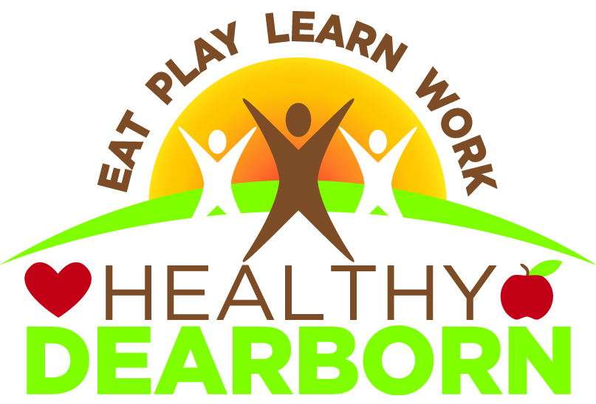

**Healthy Dearborn was launched in 2015**.

* Robust, diverse, committed coalition of 325+ members that meets monthly
* Institutional support from Beaumont, City of Dearborn and Dearborn Public Schools
* Staff support
* Ongoing partnership with three universities – research, resources and more than 70 student interns engaged in hands-on projects and learning
* Secured $1.2 million private funding for Bike Share program, six-mile Outer Drive bike trail, after-school physical activity programs, Power of Produce at Farmer’s Market
* Wednesday Walk & Roll launched in 2016 with more than 750 participants & growing
* Healthy Dearborn Homecoming presence
* Raised $2,500 for neighborhood bike path
* HD Website, Facebook page & Healthy Dearborn Walk & Roll Facebook Page w/700+ likes, Twitter and Instagram accounts; student intern now developing newsletter
* Revised, voluntary DPS District Wellness Policy to increase nutrition education and physical education activities
* Developed nutrition education lesson plans for K-5 teachers in Dearborn Public Schools
* Launching Healthy Restaurants program to encourage and highlight healthy meals
* Launched new “Transformation Tuesdays” fitness program in partnership with First Responders, City of Dearborn Recreation Department and Fairlane Town Center – in talks to continue this year round
* In partnership with City of Dearborn, held three Annual Family Bike Rides, and two Homecoming Bike Rides, attracting 400 new riders
* Launching seed library in Dearborn Public Library to encourage home gardening
* In partnership with City of Dearborn, selection of consultant to develop Multi-Modal Transportation Plan
* Student intern completed mapping of physical activity resources in target areas
* Preliminary work on food access survey
* Electronic worksite wellness survey and new partnerships with two organizations to provide free worksite wellness consultation and resources to interested employers
* In partnership with Drs. Sampson & Price, submitted grant for student training and advocacy around air pollution issues in South End

**ATTACHMENT B  
  
OUR HEALTHY DEARBORN, HEALTH EQUITY TASK!**

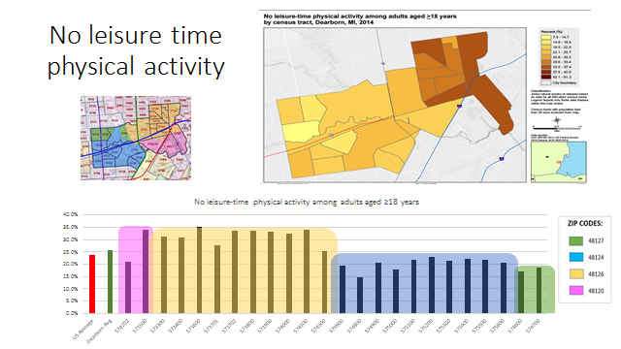 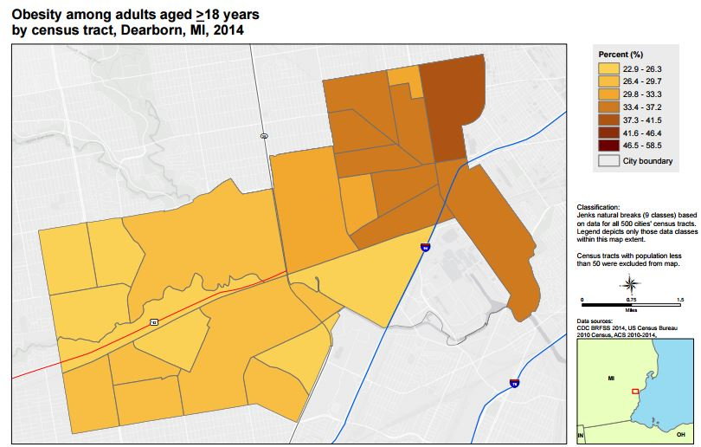

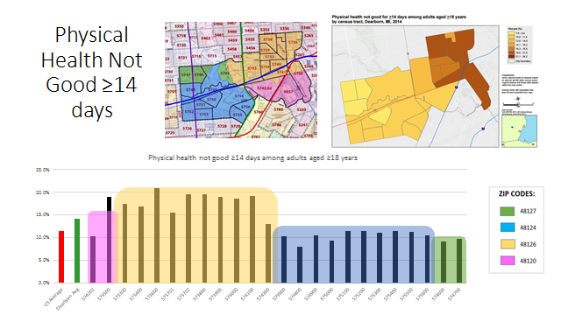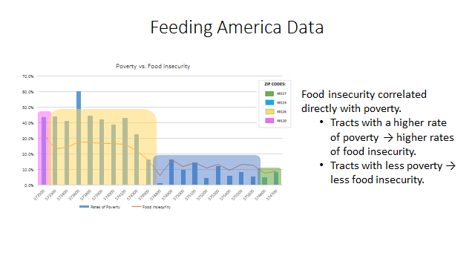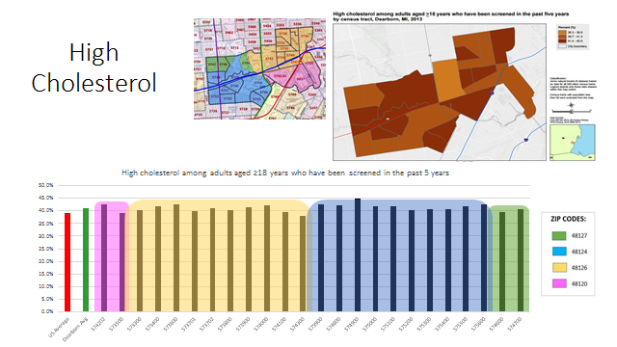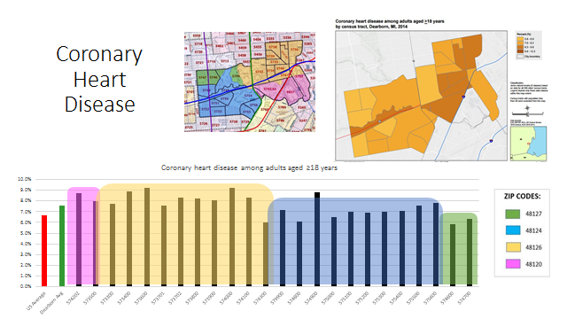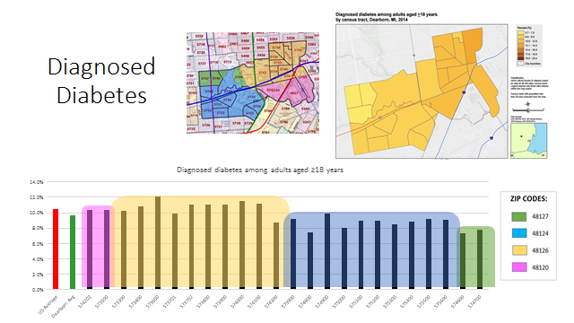

**Health equity means offering the resources necessary for everyone to be at their healthiest.**

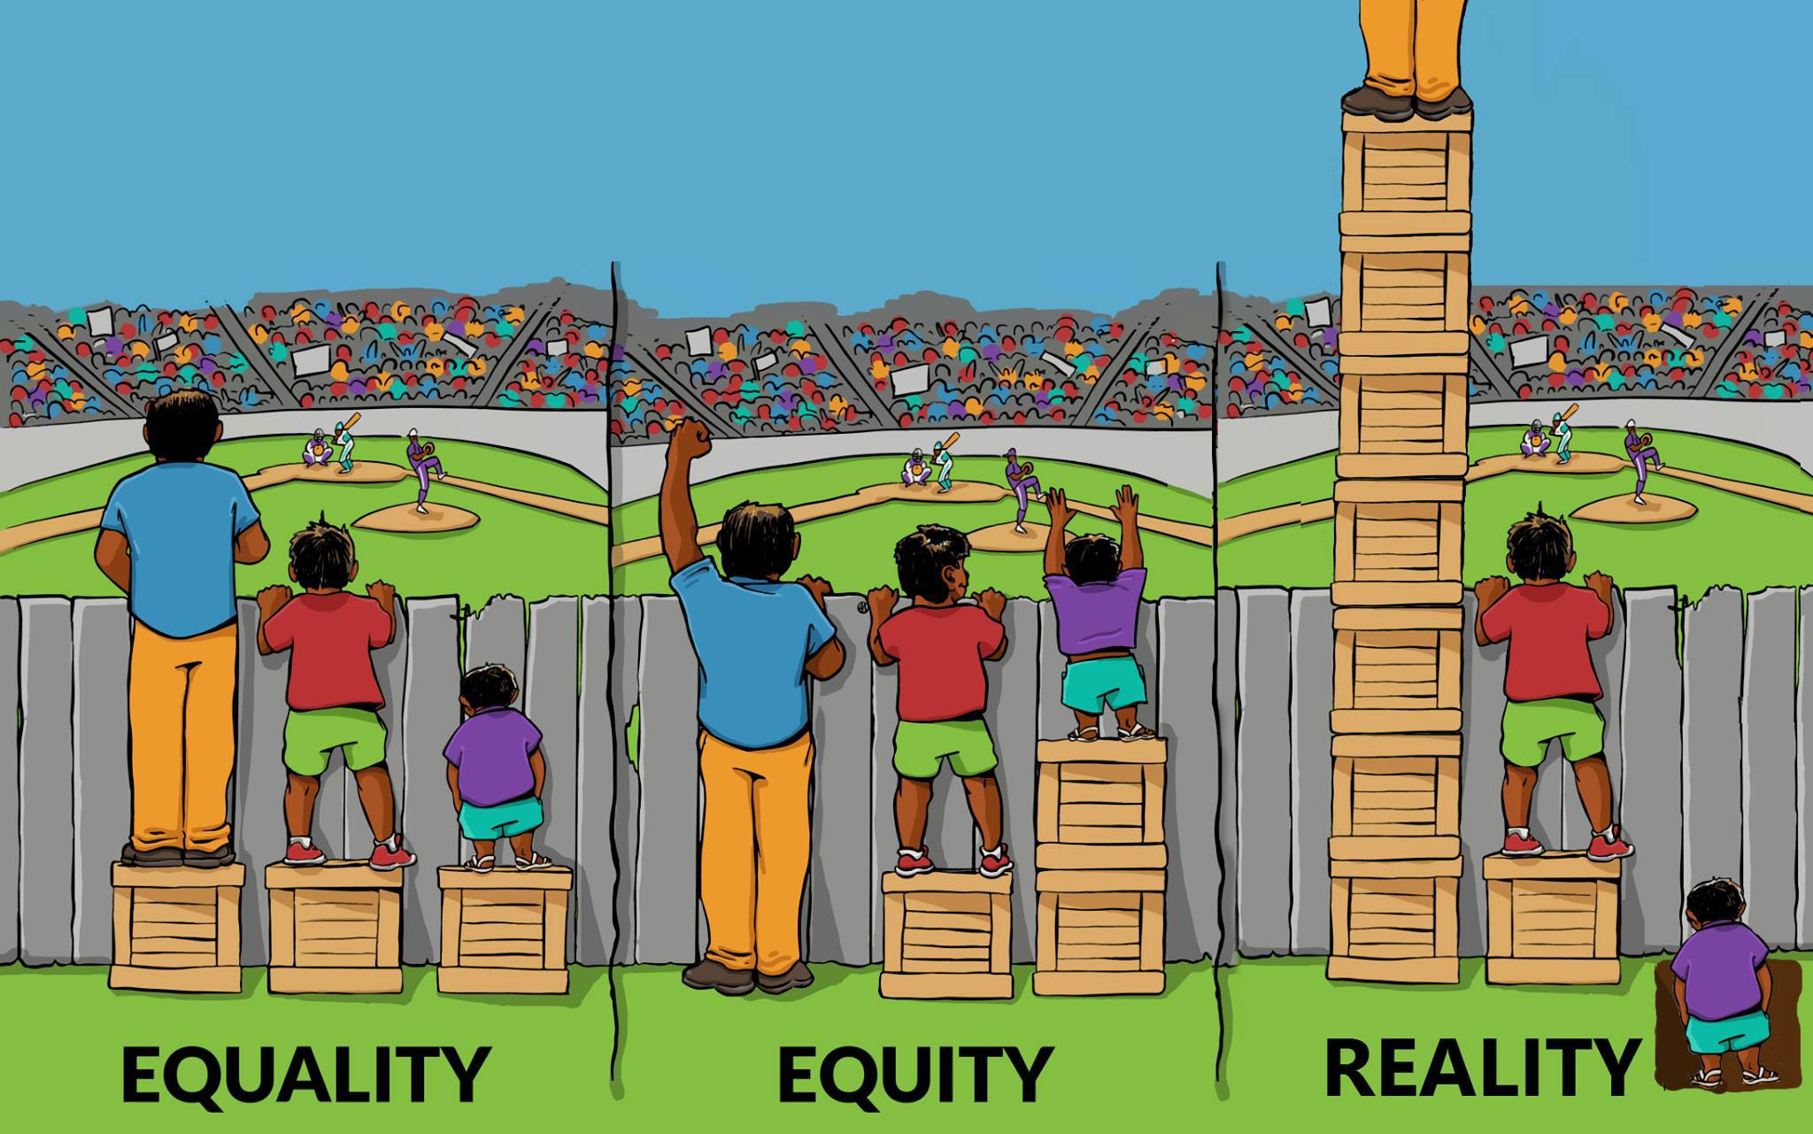

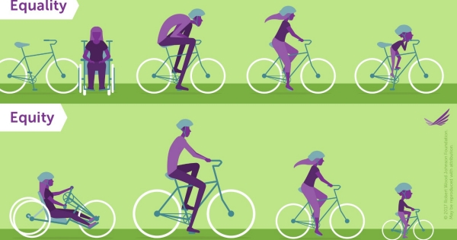

**Who in our community may not have a fair chance to achieve their health potential? How do we shape and govern our communities so that everyone has the opportunity for good health?**

**ATTACHMENT C**

**HEALTHY DEARBORN ACTION TEAM ACTIVITIES & PROJECTS**

**Healthy Foods**

* Preliminary survey of availability & affordability of healthy foods in Dearborn
* Seed Library project in progress to encourage gardening
* Healthy Restaurant project in progress to raise awareness of healthy foods and increase availability & accessibility of healthy foods in Dearborn restaurants
* Participation in Dearborn Farmer’s Market committee
* Proposed but not in action: Double Up Food Bucks expanded in Dearborn

**Healthy at Play**

* Completed map and excel spreadsheet of physical activity resources in Dearborn, in targeted health disparity areas as well as more affluent areas
* Launched Transformation Tuesdays in summer of 2017; working to expand it in partnership with Fairlane Town Center & First Responders for Fitness
* Successfully advocated for launching of Healthy Dearborn website

**Healthy Schools**

* Developed new and revised School Wellness policy guidelines
* Developed healthy nutrition education lessons for K-5 students/teachers
* With WSU, implemented survey at Henry Ford elementary school, resulting in recommendations for improving physical activity and healthy nutrition
* Created “brain breaks” materials
* Began enlisting school principals to apply for Safe Routes to Schools funds
* With Kosch funding, in process of installing after-school physical activity program, CATCH Kids Club, in six elementary schools

**Healthy Transportation**

* Launched Walk ‘N Rolls, implemented for two years
* Launched and held three HD Family Bike Rides
* Launched and held two Homecoming Bike Rides
* Survey of bike & walk conditions in one neighborhood/quadrant
* Mobilized key stakeholders & obtained consensus on need for multi-modal transportation plan for Dearborn; in process of selecting a Consultant to help develop this plan for Dearborn
* With Kosch funding, launched Bike Share program with ten stations & in process of completing Outer Drive Bike Trail
* Obtained $2500 for neighborhood bike trail route

**Healthy at Work**

* Developed survey to assess interest among businesses for worksite wellness program engagement
* In process of engaging business community to encourage them to take the survey and implement worksite wellness programs

**ATTACHMENT D**

**Healthy Dearborn  
Inventory of Assets**

At its September 22, 2015 Healthy Dearborn coalition meeting, community members identified Dearborn’s strengths and resources that can be used and built upon to improve community health. Additional assets are identified in the City of Dearborn Master Plan and City of Dearborn Recreation Master Plan.

As you review the following asset inventories, ask yourself:

1. What does an equitable, Healthy Dearborn look like?  
  
2. How can we use these assets to build a culture of health?  
  
3. What are the biggest opportunities you see for collaboration and changes   
 needed in order to improve residents’ health?   
  
4. Where do you see gaps? Who needs to be added?

**INDIVIDUALS – COMMUNITY MEMBERS**

* Nadia Al Kalil, weight loss
* Ali Baleed Almaklani, Yemeni community
* Suehaila Amen – UMD
* Najah Bazz, Zaman International
* John Elkins, Community Outreach, St. Mark Mercy Livonia, past president of DFCU
* Fr. Jim Divine Child,
* Ali Hammoud, Arab American Political Action Committee
* Health Plan reps from city, schools, businesses
* Linda Hively, Resident of Henry Ford village
* Dr. Stan Jensen, Henry Ford College
* Dr. Kamal Khalil
* Craig Kotajarvi, U of M Healthy Wellness Program coordinator
* Senior volunteers
* Jehad Majda, Adolescent Health program,
* Jehad Najda, certified personal trainer
* Adam Sterling, marketing coordinator Henry Ford Village
* Madiha Tariq, ACCESS
* Matthew Wallace, fitness director, HF Village
* Oakwood Healthcare volunteers

**BUSINESSES**

* AAA of Michigan
* Al Ajami Restaurant east & west
* Andiamo’s, The Henry
* Arab American News
* Athletica Fitness Center
* Bozii - founded by a chef, new vendor in Fairlane Mall Food Court
* Byblo’s Banquet – Yousef Bazzi
* Carhartt
* Dance Studios for kids, Sickle’s
* Dearborn Chamber of Commerce
* Dearborn Community Fund
* Dearborn Farm Market
* Dearborn Federal Credit Union
* Dearborn Federal Savings Bank
* Dearborn Fresh
* DTE Energy
* East & West DDA
* Eppinger
* Fairlane Mall
* Fitness Yoga classes
* Ford
* Ford Employees Recreation Association
* Ford Land
* Ford Motor corporate Employee Wellness
* Ford Motor Fund employees
* Ford/Team Detroit
* Ghafari
* Gold’s
* Greenland
* Grocery stores – Kroger
* HYPE Athletics
* Jack’s Bike
* La Fitness
* La Pita
* Lear
* Panera Bread
* Powerhouse,
* Press & Guide
* Renwood Farms
* Restaurants
* Saatra Yoga studio
* Severstal
* Specialty food store owners
* Times Herald
* Visteon
* Westborn
* Western Wayne Federally Qualified Health Center
* Whole Foods
* Yoga facilities

**Local, public & nonprofit institutions, organizations** **& programs**

* ACCESS
* American Assn. of University Women
* American Cancer Society Relay for Life
* Arab American Chamber of Commerce
* Arab American Women’s Business Council
* ARC of Dearborn
* Beaumont Health
* Boy Scouts
* Communities of faith
* Cycling Saddlemen
* DACC
* DCC
* Dearborn Area Interfaith Network
* Dearborn Artspace
* Dearborn Baseball  
  Dearborn Basketball
* Dearborn Cheerleading
* Dearborn Commission on Disabilities
* Dearborn Community Arts Council
* Dearborn Community Tennis Association
* Dearborn Farmers & Artisan market
* Dearborn Figure Skating Club
* Dearborn Historical Museum
* Dearborn Hockey Association
* Dearborn housing
* Dearborn Library
* Dearborn Public Library Foundation
* Dearborn Recreation & Parks Commission
* Dearborn Soccer Club
* Dearborn Theater Group – outreach!
* Dearborn Public schools/sports programs
* Dearborn Soccer
* Dearborn Track
* Dearborn Walking Club
* Dearborn Youth Affairs Commission
* Dearborn Youth Football Association
* DMC
* Fairlane Racquet
* FDAS - Mutt Strut
* Ford Community & Performing Arts Center
* Friends of the Dearborn Library
* Friends of the Rouge
* Detroit Medical Center
* Garden Club
* Goodfellows
* Henry Ford Village retirement community
* High school diversity groups to include all students
* HYPE
* Information Center
* Interact, HS Clubs
* The Islamic Center of America
* Key Club
* Kiwanis Club
* Lebanese groups – LAHC, Lebanese Chamber
* Libraries – sites for community outreach
* Liquid Nutrition program
* Lutheran parishes
* Marathon Running Fit
* Martian Marathon
* Meals on Wheels
* MS group
* National Arab American Nurses Association
* National Kidney Foundation
* Neighborhood Associations
* NHS high school
* Optimist Club
* Parkinsons Group
* Playground programs/Summer camps
* Sacred Heart parish
* Schools
* School physical education teachers
* SEMCOG
* Senior Commission
* Senior services
* Silver Sneakers
* SW Detroit Environmental Vision
* Special Olympics
* TEFAP (County)
* The Senior Alliance

**Local, public, nonprofits, organizations** **& programs, cont.**

* UM Dearborn, Henry Ford, Wayne CCCD
* UMD Environmental Interpretive Center
* U of Michigan Project Healthy Schools
* U of M Dearborn Wellness Center
* UMD Student Government Health & Wellness Taskforce
* Unions
* Walking club at Fairlane Mall
* Wayne County Health
* Veterans & Community Wellness
* Yemeni groups – NAYA, YABA, YAA

**TRANSPORTATION**

* Bike Share
* Bike trail
* Dial-A-Ride – expansion
* Information Center
* New light rail
* Non-motorized transportation plan
* Senior Alliance
* Senior housing
* SMART
* SMART Connector
* Wayne County Transit Authority representative

**PHYSICAL STRUCTURES**

* All Dearborn Rec facilities
* Beaumont Hospital Dearborn Fitness Center
* Bike lanes – education, awareness, respect
* Camp Dearborn
* Dearborn Ice Skating Center
* Dearborn parks (Crowley, Ford Field, Ford Woods, Hemlock, Lapeer, Levagood)
* Dearborn schools facilities
* Elizabeth Park, walk, hiking, workout equipment
* Farmers Market structure in east downtown Dearborn authority?
* Ford Community & Performing Arts Center & Michael Guido Theater
* Fort Rouge Gateway Project &Rouge Gateway Trail
* Golf courses
* Grosse Ile non-motorized boat launch
* Hines Park Dearborn area
* Need more indoor activity centers during winter
* Pegs Trail
* Transform Fairlane Town Center into a fitness place during winter
* Walking tracks at neighborhood schools
* Walking trails for walking and exercise